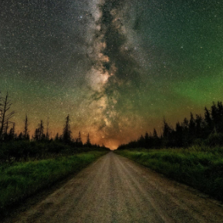
Northern Minnesota Recreation and Parks Association
Monday, February 14
11:00 AM

- Round Table/Introduction- Most exciting thing you are looking forward to this summer season?? Could be a project, program, event or new funding source.
  - Please limit updates to 2 minutes
- Nisswa- working on Master Planning
- Hutchinson- 2 playground in the works, Fireman’s Park & re-evaluating upcoming events
- Monticello- working on Farmers Market, Pickleball, Fab Bike Festival & swim lessons
- Isanti- working on landscaping and concert series
- Wright County-Creating a fly-fishing program
- Elk River- Planning programming at the skate park with 3rd Lair, kayaking & paddle boarding, Riverfest Community Event at Lion’s Park, Tennis Courts Bids
- Buffalo- working on pickleball courts at Neighborhood Park
- Otsego- Farmer’s Market
- Bemidji- working on two park project/re-models, summer camp planning

- MRPA Updates
-Upcoming Education: Emerging Recreation Leaders Institute 2
-Pickleball & Softball Tournaments will be happening this summer

- Large Group Discussion- When do you start hiring seasonal staff?? What has been the most successful posting source or the best place to recruit staff??
- Elk River- Already posted, great success with Indeed, looking at a mix of high school and college students, partnering with High School teams to coach sports
- Buffalo- Hiring 30 seasonals, all maintenance/boat rental related, post through NeoGov
- Quick Breakout Groups
  - Programming Group- Which Holidays do you program/celebrate? Are there any holidays you stay away from?
- Otsego- switched more registration to pre-register rather than drop ins, do celebrate Easter & Santa Events, working on a multi culture festival
- Several groups adding Juneteenth celebrations
- People Fest in Eden Prairie
  - Maintenance Group- Best way to communicate with staff?
- Earlier the better
- Meeting with programming staff (weekly with agendas)
- Create a calendar with reminders, can use a Google Doc
  - Directors Question- Funding Sources/Grants (what works what doesn’t work, any unique partnerships??)
- Anything Else & Upcoming Meeting – March, maybe in person?? Possible panel discussion??
Kayak/Paddleboard Class- Erin with Peace of Mind Paddling. http://box5913.temp.domains/~peaceoo6/
Construction Manuals for courts - https://sportsbuilders.org/page/OnlineStore

